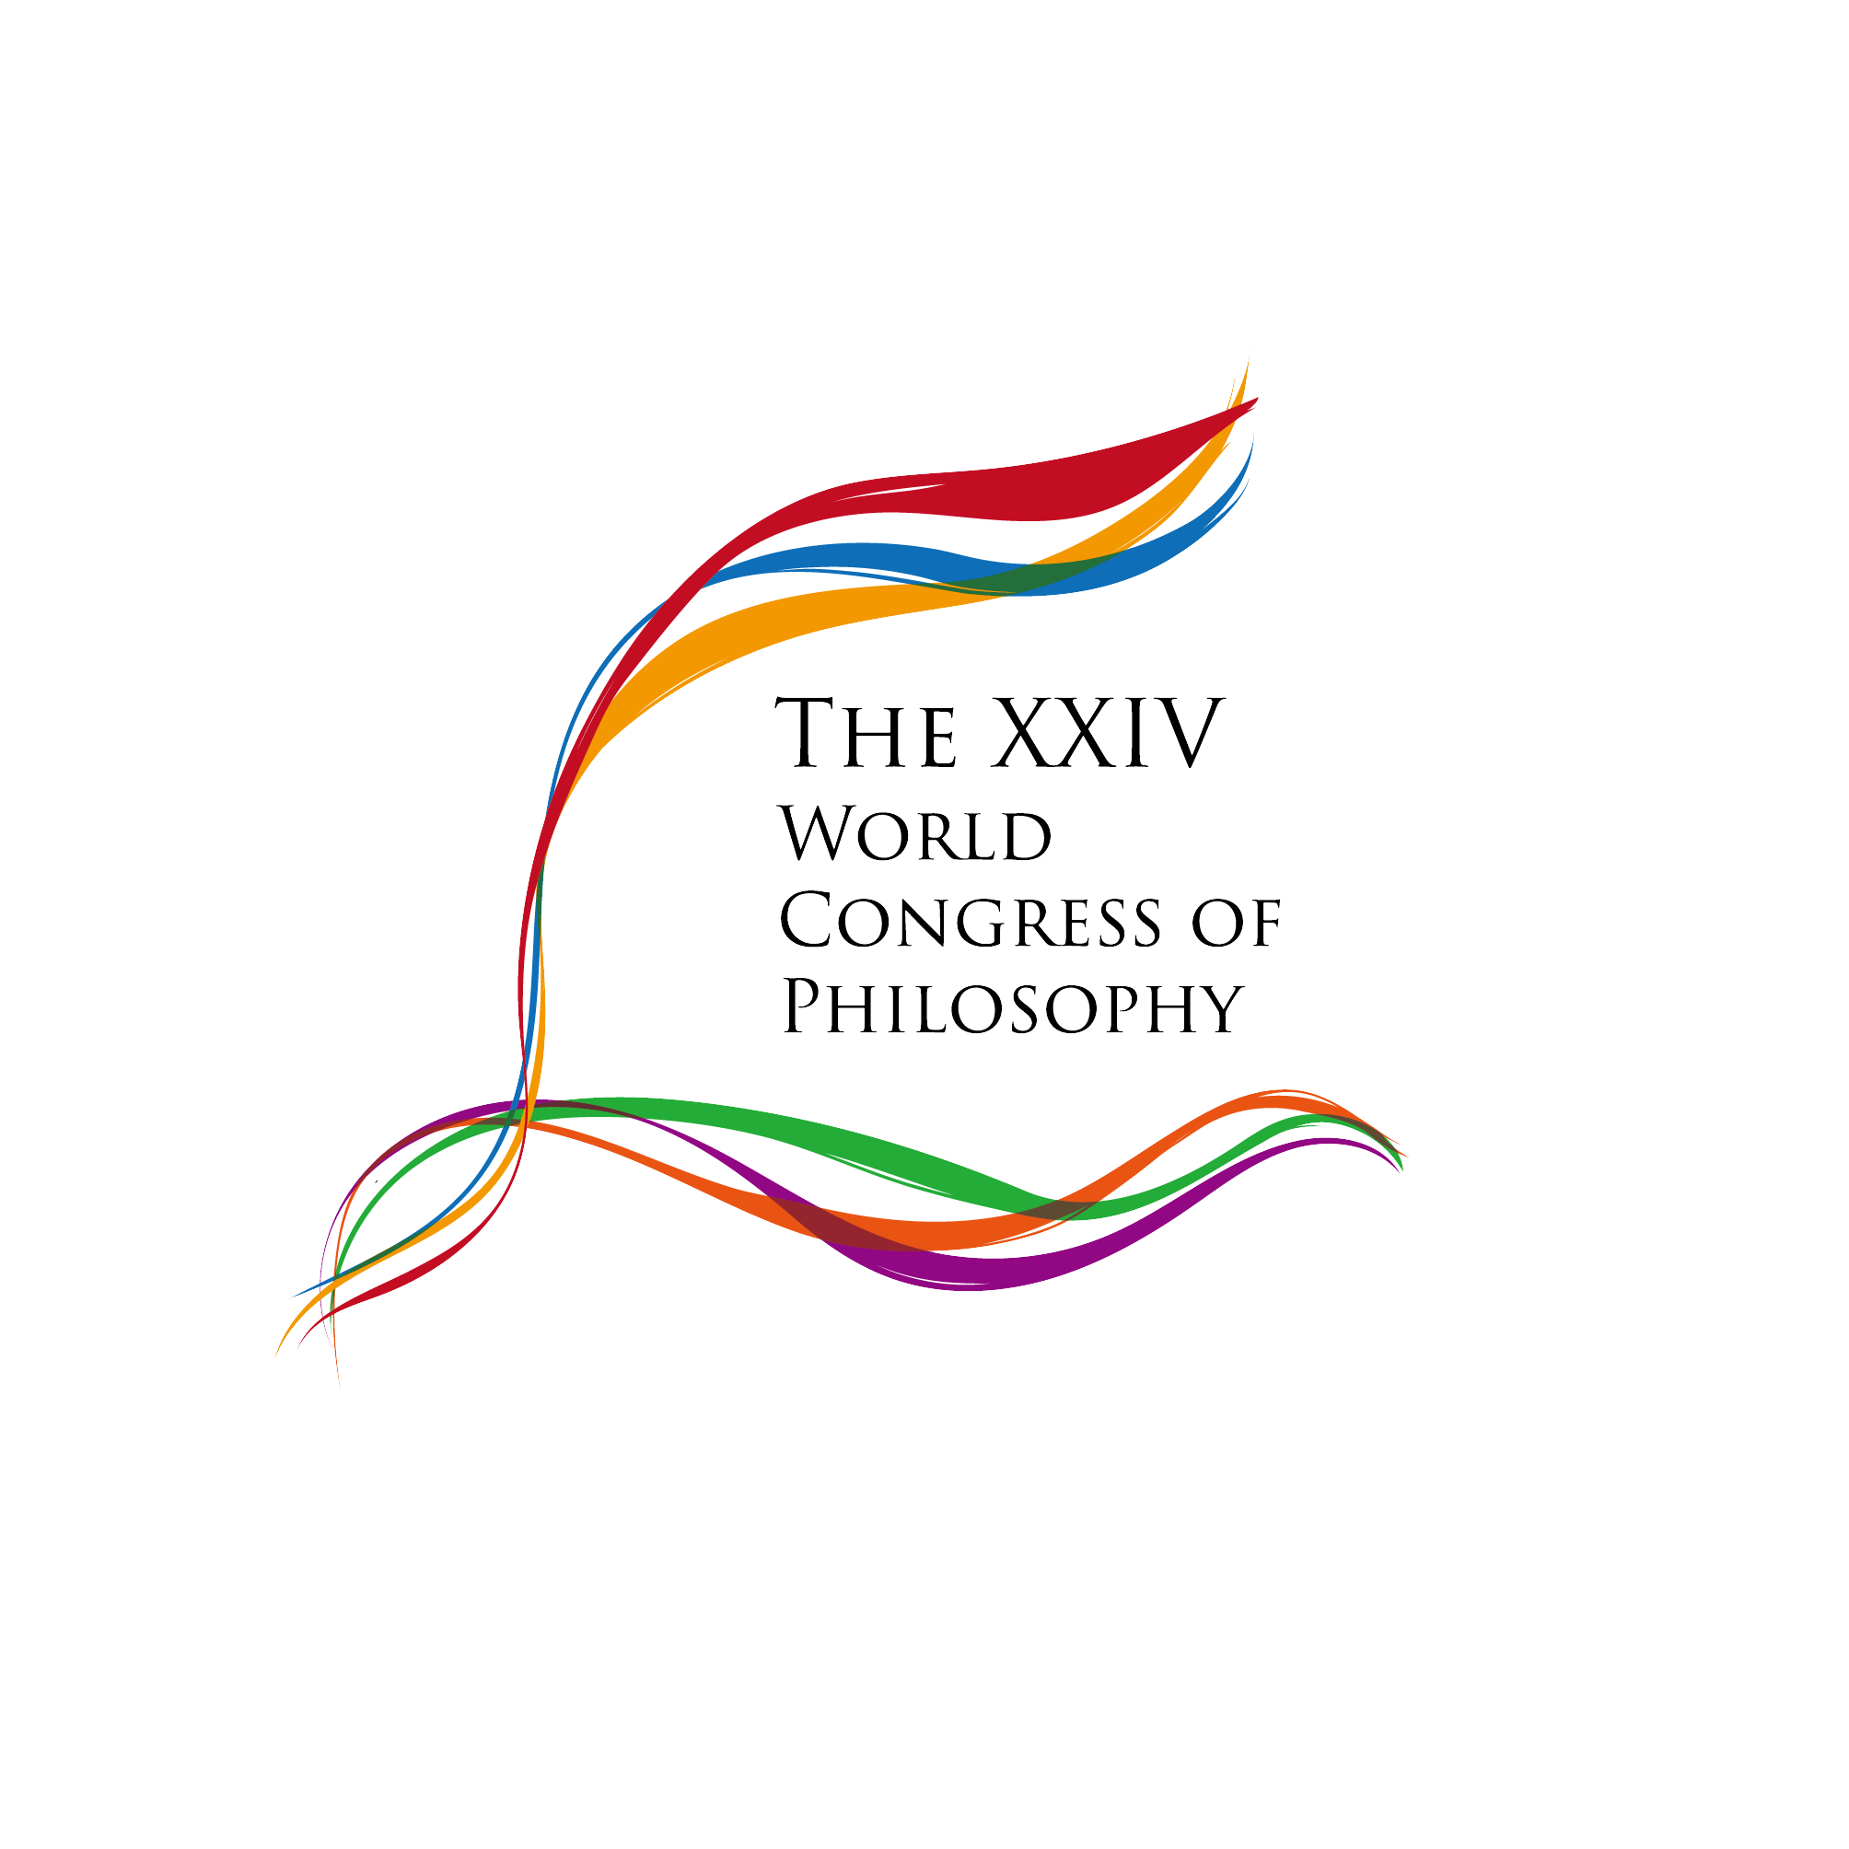 | 24th World Congress of Philosophy (WCP 2018)  Beijing, 13 – 20 August 2018  Department of Philosophy, Peking University
Proposal Submission Form - Round Table
(All fields marked with * should be completed and written in English to avoid technical problems)
1) ORGANIZER(S)
Country:

Organizer* (Check either Society or Individual ) :
□ Society : (Name of the Society)
□ Individual :
Title ☑ Prof. □ Dr. □ Mr. □ Ms.
First (Given) Name: Last (Family) Name:
Affiliation *:
Address *:
Postal Code*:
Phone Number *:
Fax Number:
* E-mail Address:
Date; Signature:
2) PROPOSAL TITLE
3) SPECIAL REQUESTS (e.g., dates, schedule, facilities, etc.) – IF APPLICABLE
4) PARTICIPANTS MUST REPRESENT AT LEAST THREE DIFFERENT NATIONALITIES.

Participant 1

First (Given) Name*
Last (Family) Name*:
Title □ Prof. □ Dr. □ Mr. □ Ms.
Affiliation*:
Country*:
Email*:
Ttile (optional):

Participant 2

First (Given) Name*
Last (Family) Name*:
Title □ Prof. □ Dr. □ Mr. □ Ms.
Affiliation*:
Country*:
Email*:
Ttile (optional):

(please add the full list of participants)

Abstract of Round-table
(optional)

