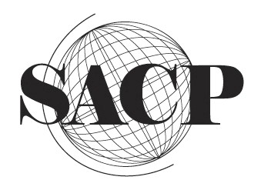 |  |  | Conference Registration Form  Society for Asian and Comparative Philosophy  2018 Annual Conference  Theme: Power and Creativity  50th Annual Conference  June 8-11, 2018  Pedagogical University of Cracow  Poland
Name:
Institutional Affiliation:
Department:
Position: | Professor    |  |  | Retired / Emeritus   |  | Graduate Student   | Independent Scholar  
Mailing Address:

Street Address
City State Zip Code Country Country Code
Email Address:

Phone Number:

Early Registration  Prior to March 31, 2018 |  | - SACP Member – Regular |  |  |  |  |  |  USD 160
 |  | - SACP Member – Emeritus / Student / Non-Presenting Participant / Local Participants Discount |  |  |  |  |  |  USD 125
 |  | - Non SACP Member Regular |  |  |  |  |  |  USD 200
 |  | - Non SACP Member Emeritus/Student |  |  |  |  |  |  USD 150
Late Registration  Until May 15, 2018 |  | - SACP Member – Regular |  |  |  |  |  |  USD 200
 |  | - SACP Member – Emeritus / Student / Non-Presenting Participant / Local Participants Discount |  |  |  |  |  |  USD 150
 |  | - Non SACP Member Regular |  |  |  |  |  |  USD 250
 |  | - Non SACP Member Emeritus/Student |  |  |  |  |  |  USD 175
Please go to http://www.sacpweb.org/ to pay your registration fee, as well as SACP membership dues if they have not already been paid. All payments are to be made through PayPal at the SACP website unless otherwise arranged. Once completed, this form can be emailed back to sacpweb@gmail.com as an attachment. |  |  |  |  | Registration fee includes: the conference materials, refreshments and three lunches (Sat-Mon), welcome reception, conference dinner, optional guided tours at the National Museum in Krakow.

